IMPLEMENTING CONDITONAL ACCESS POLICIES, INCLUDING MFA

STEP-01

CREATING CONDITIONAL ACCESS POLICIES. TO GET TO THE LOCATION IN THE IMAGE BELOW GO TO AZURE AD 🡪 SECURITY 🡪 CONDITIONAL ACCESS

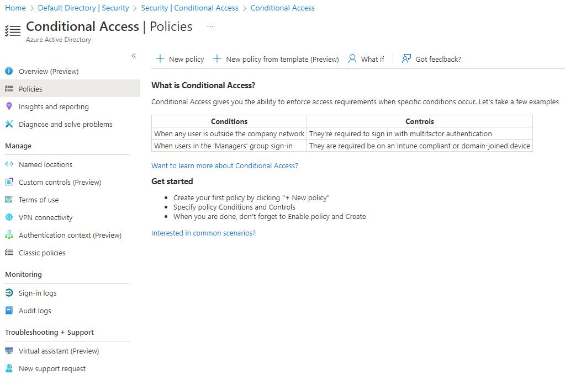

STEP-02

AS SHOWN IN THE IMAGE BELOW CREATING CONDTIONAL POLICIES IS NOT SOMETHING YOU CAN JUST CONJOUR UP. THEY HAVE TO A MEANINGFUL TO YOUR ORGANZATIONAL AS YOUR SPECIFIY WHAT USERS AND APPLICATIONS CAN BE ACCESS.

FOR THIS LAB I AM DOING A TWO FACTOR CLOUD POLICY. FOR USERS I INCLUDED MIKE WALTON WHO IS THE BILLING ADMIN AND ANOTHER USER SARAH, BUT I ALSO EXCLUDED USER JENKINS. YOU CAN ALSO DO THE SAME WITH CLOUD APPS

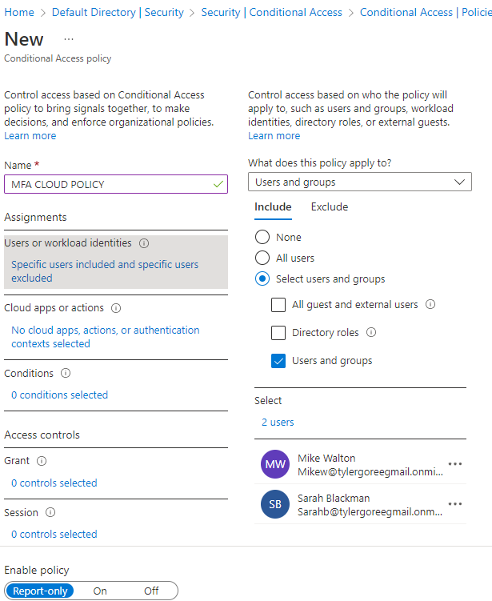

STEP-03

TO GRANT OR DENY ACCESS YOU CONDFIGURE THOSE OPTION UNDER THE GRANT TAB. AS SHOWN BELOW I HAVE CONFIGURED THIS POLICY TO GRANT ACCESS AND REQUIRE INCLUDED USERS TO MULTIFACTOR TO ACCESS ORGANIZATIONS RESOURCES.

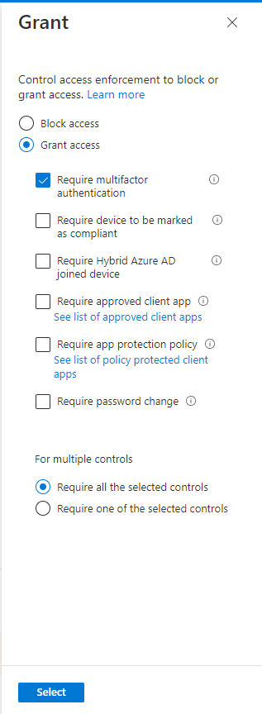

#### OPTIONAL ####

IF YOUR WANTING TO GO DEEPER IN THE RESTRICTIONS OF YOUR CONDTIONAL POLICY YOU GO UNDER THE CONDITIONS TAB. FROM THERE YOU HAVE VARIOUS SUB-SECTIONS YOU CAN ENABLE. FOR THIS LAB I CHOOSE NOT TO CONFIGURE ANY OF THOSE AT THIS TIME.

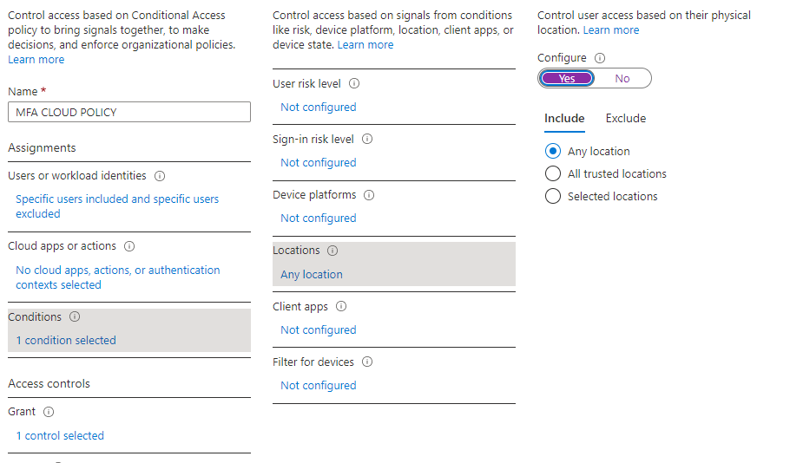

BELOW IS MY FIRST SUCCSSFUL CONDITIONAL POLICY. FOR THIS LAB, I JUST WENT WITH REPORT ONLY, BUT IN A PRODUCTION ENVIORNMENT YOU WOULD TURN IT ON.

NOTE: YOU CAN TURN THIS POLICY TO ON BY EDITING THE POLICY.

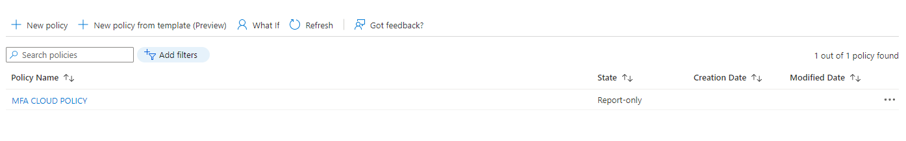

FOR MORE INFORMATION CHECKOUT: [Conditional Access - Require MFA for all users - Azure Active Directory - Microsoft Entra | Microsoft Docs](https://docs.microsoft.com/en-us/azure/active-directory/conditional-access/howto-conditional-access-policy-all-users-mfa)